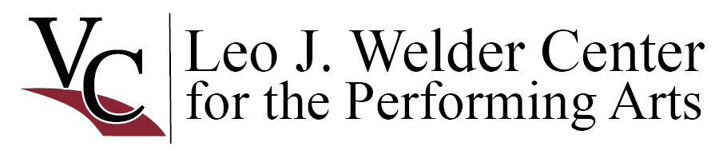

FREQUENTLY ASKED QUESTIONS
Please refer to the full Operating Guidelines for detailed information about holding events at the Welder Center.

Ticketing If you are selling or giving away tickets to events at the Welder Center, you must use our ticketing system. See the box office policy for prices and fees.
Marketing/Promotions Use the facility’s full name as the location for your activity in all print, radio, television and film materials:
Leo J. Welder Center for the Performing Arts Shorten this name to Welder Center only after the full name has been utilized in the same marketing piece. Promotional materials should include information about parking.
General Usage of the Facility Consult the Welder Center staff when scheduling load-in and load-out times. Times must be strictly adhered to by client in order to accommodate the many users of the Welder Center. Consult with Welder Center staff about any equipment or materials that may be delivered early or left after events; do not leave materials in the hall, lobby or loading dock without permission.
Rehearsals, Sound Checks, Client Set-Ups Dates and times for rehearsals, sound checks, client set-ups and/or load-ins must be clearly indicated on the rental information sheet and will be charged accordingly. Performers and participants should enter through the Stage Door for rehearsals and sound checks; the facility user is responsible for monitoring access. Invited dress rehearsals and any other usage of the Welder Center lobby that includes entrance and egress by public or participants must be monitored by a house manager and must be clearly indicated on the rental information sheet. Client will be charged for house managers required for these activities.
Parking Curbside parking is available downtown from 8am – 5pm, Monday – Friday. The parking lot behind the Welder Center is a private parking lot; it is available for use by clients and their audiences only after 5pm on weekdays and at any time on weekends. The One O’Connor Plaza parking garage is also available after 5pm on weekdays and at any time on weekends.
Parking is never allowed on the concrete sidewalk by the Stage Door as it is not rated for vehicle weight. Promotional materials for your event should encourage your attendees to park appropriately.
Posters, Decorations During your event, signs should be displayed on an easel or other display which you furnish. Signs and posters may not be taped to the walls or doors at the Welder Center. Promotional posters will be displayed in advance of your event in the Welder Center marquee as space allows. Marquee size is 24” x 36”. No balloons, glitter, or lit candles allowed.
Tables/Tablecloths A limited number of tables may be available for your event; check with Welder Center staff regarding availability when scheduling your event. Unclothed tables are discouraged; a limited number of Welder Center tablecloths are available for a $5 per cloth cleaning fee.
Clean-Up Volunteer ushers and client’s staff are expected to assist with picking up programs, etc. left in the performance hall after and between events. If permission is received to use ice-chests or have activities that may create a mess, protect the lobby’s carpet with vinyl or plastic mats.
Concessions The Concessions Bar will be open for full service (wine, beer, soft drinks, water, snacks) during your event unless previous arrangements are made with the Center. Only Welder Center employees may staff the concession stand. You may choose to bring your own water to provide to your presenters or purchase water from the Welder Center concessions.
Alcohol Victoria College holds a TABC beer and wine license for sales at the Welder Center. Therefore, any service of alcohol must be within the strict mandates of TABC regulations. Before you plan to serve alcohol, check with the Welder Center staff.

